SAVEETHA INSTITUTE OF MEDICAL AND TECHNICAL SCIENCES
DEPARTMENT OF ELECTRONICS AND COMMUNICATION ENGINEERING

SUBJECT NAME: MICROWAVE ENGINEERING
SUBJECT CODE: ECA1308
STUDENT NAME: T. M. Rishika
REGISTRATION NUMBER: 192412200
EXPERIMENT NO 2

EXPERIMENT 2A
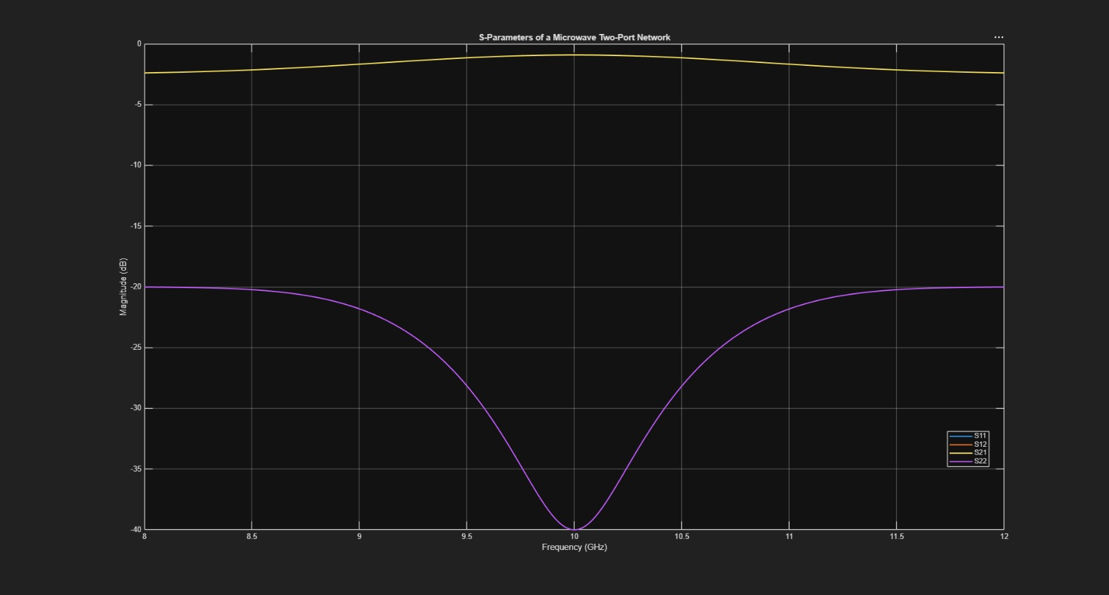

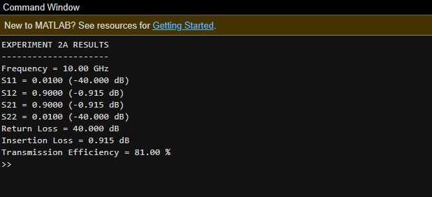

EXPERIMENT 2B
